Day 12

**Day 12**

1. Calculate year wise, month name wise count of orders and year over year (YoY) percentage change. Format the YoY values in no decimals and show in % sign.

Table: Orders

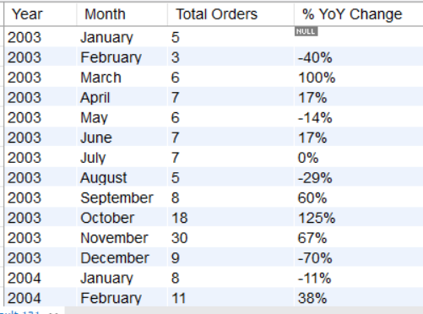

Ans)

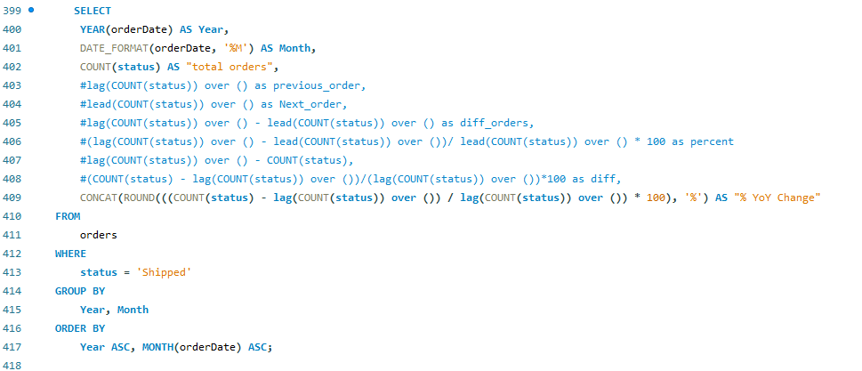

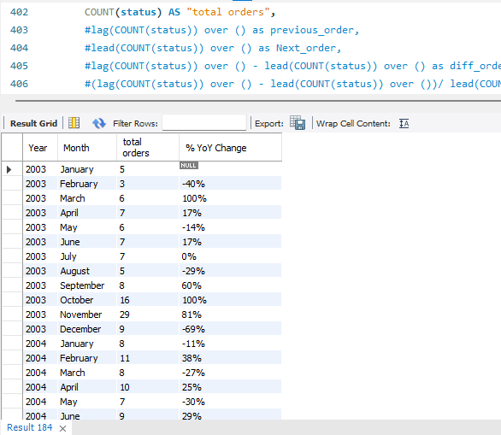

1. Create the table emp_udf with below fields.

* Emp_ID
* Name
* DOB

Add the data as shown in below query.

INSERT INTO Emp_UDF(Name, DOB)

VALUES ("Piyush", "1990-03-30"), ("Aman", "1992-08-15"), ("Meena", "1998-07-28"), ("Ketan", "2000-11-21"), ("Sanjay", "1995-05-21");

Create a user defined function calculate_age which returns the age in years and months (e.g. 30 years 5 months) by accepting DOB column as a parameter.

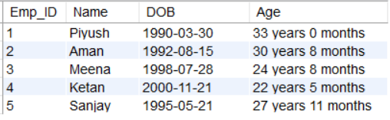

Ans)

